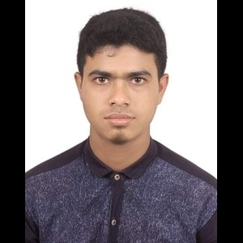**CV of Md. Laku Mia**

|  |  |  |
| --- | --- | --- |
| Name | : | Md.Laku Mia |
| Father’s Name | : | Md. Nazrul Islam |
| Mother’s Name | : | Most. Lovely Begum |
| Date Of Birth |  | 21/08/2001 |
| Nationality | : | Bangladeshi |
| Religion | : | Islam |
| Marital Status |  | Single |
| Gender |  | Male |
| Mobile Number | : | 01319543397 |
| Email | : | mdlaku250@gmail.com |
| Present Address |  | Village : Dokkhin Gidari, Post Office : Gidari ( 5700 ) , Upazila : Gaibandha Sadar , District : Gaibandha |
| Permanent Address |  | Hall : Shaheed Mukhtar Elahi Hall , BRUR, Post Office : Cadet College (5400) ,Upazila : Rangpur Sadar , District : Rangpur |

Basic Information :

Educational Information :

|  |  |  |  |  |  |  |
| --- | --- | --- | --- | --- | --- | --- |
| Examination | Board/University | Roll | Result | Group / Subject | Year | Duration |
| S.S.C | Dinajpur | 201511 | 4.00 | Science | 2018 | N/A |
| H.S.C | Dinajpur | 286161 | 4.00 | Humanities | 2020 | N/A |

Extracurricular activities:

1.Leadership

2.Teamwork skills

3.Commitment

4. Microsoft PowerPoint

5.Microsoft word

6.Microsoft excel

7.Teaching,tutoring,training etc.